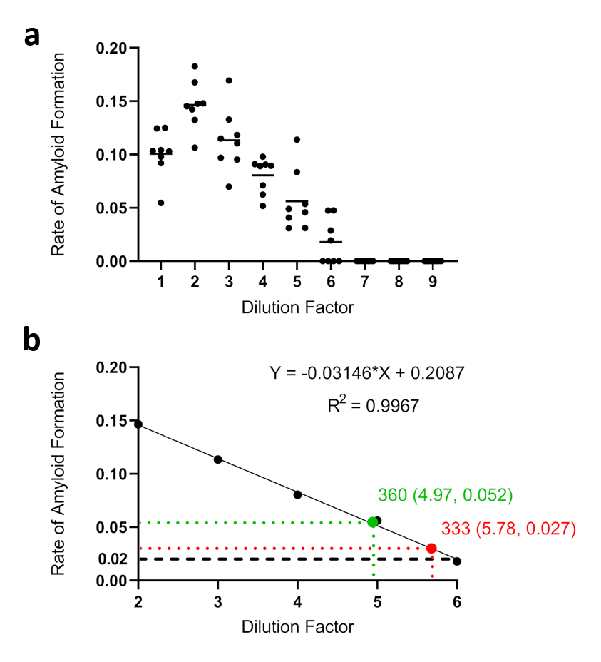

**Figure S1. Comparison of RAF (rate of amyloid formation) between lymphoid and skeletal muscle tissues.** a. RAF of 10% lymphoid tissue homogenates was plotted against dilution factors ranging from 1 to 9. The RT-QuIC experiment was set at 45°C. 8 replicates were conducted for all dilutions. b. The average of RAF from dilutions in A) with dilution factors ranging from 2-6 was fitted on a linear model. Equation and R^2 values are indicated. RAF for neck muscle samples from animal 333 and 360 processed using the freeze-thaw method and normalized to the lymphoid tissue used in a) were plotted.

Result: Prion load using muscles processed by the freeze-thaw method based on RAF from RT-QuIC results is equivalent to 10-6~10-7 (2/1000 * 10/2 * 10 * 10-5~10-6) that of lymphoid tissues, the RAF of which is 10 times lower than the brain. Therefore, in our study, the lymphoid/muscle ratio is 106~107 and the calculated brain/muscle ratio is 105~106. This is 100 to 1000 times lower than the brain/muscle ratio of 103 reported by Bosque et al.

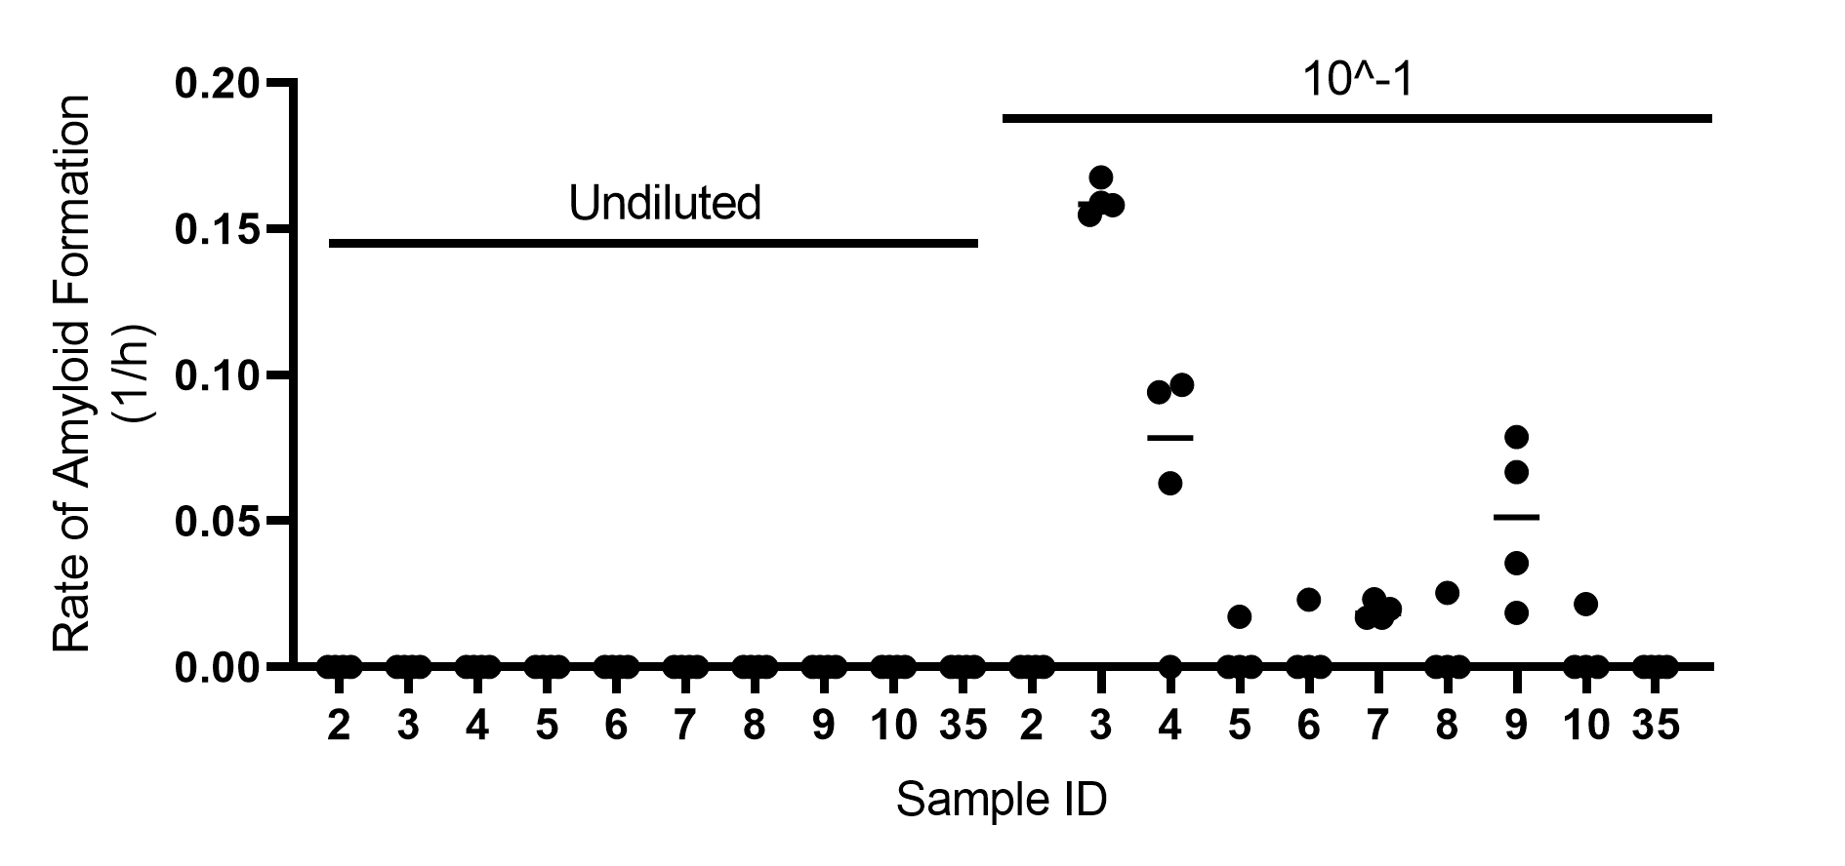

**Figure S2. Collagenase A-processed samples need to be diluted to facilitate prion-seeding activity detection in RT-QuIC.** A subset of samples with undiluted final suspension and that diluted to 10^-1 were tested on the same plate.

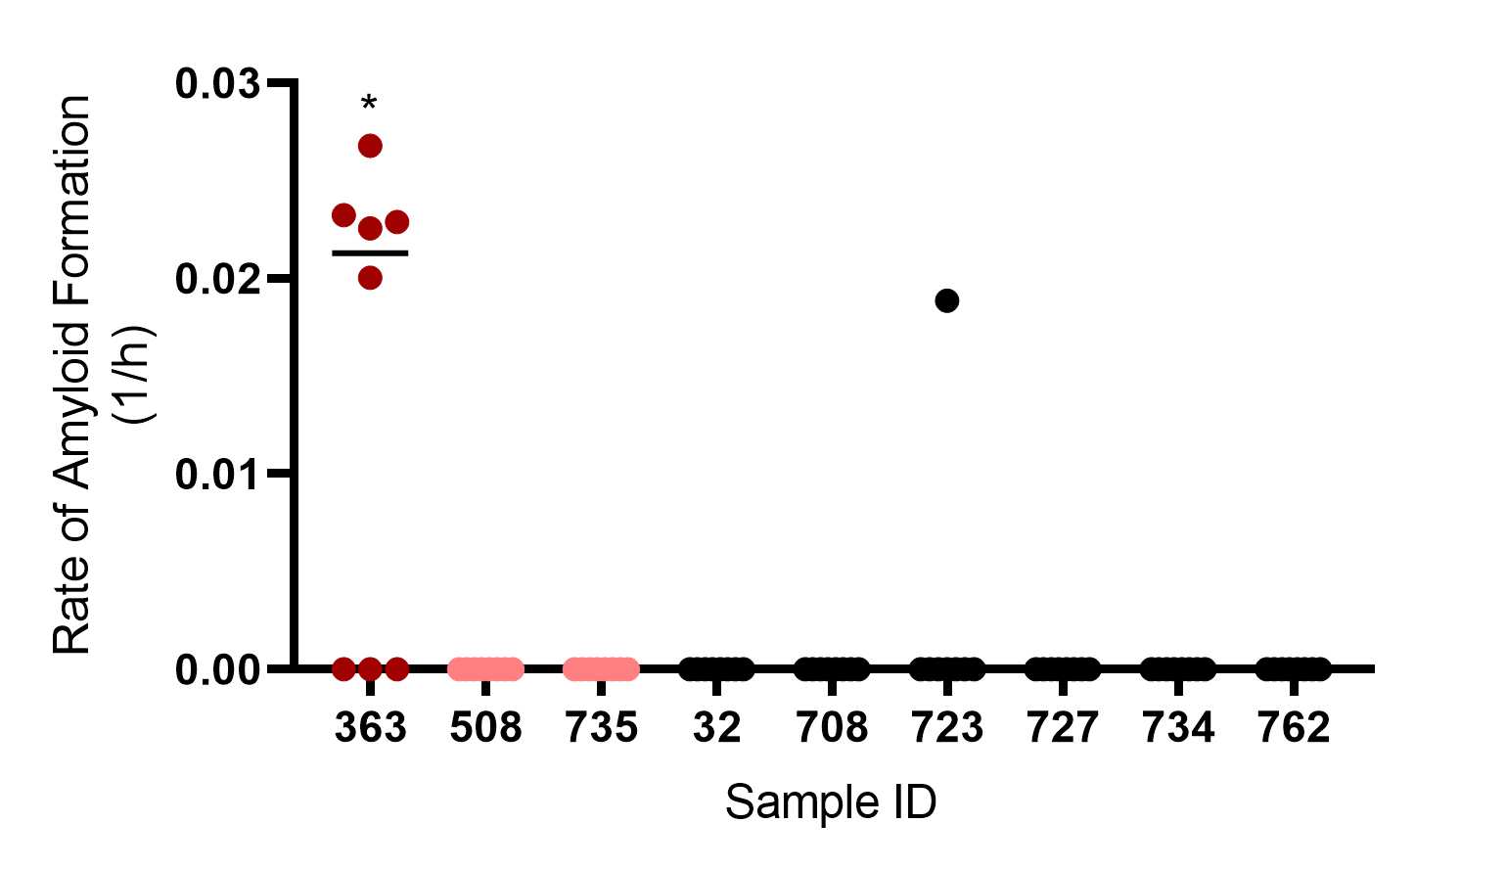

**Figure S3. Collagenase A processing does not produce significant RT-QuIC false positives for neck muscles.**

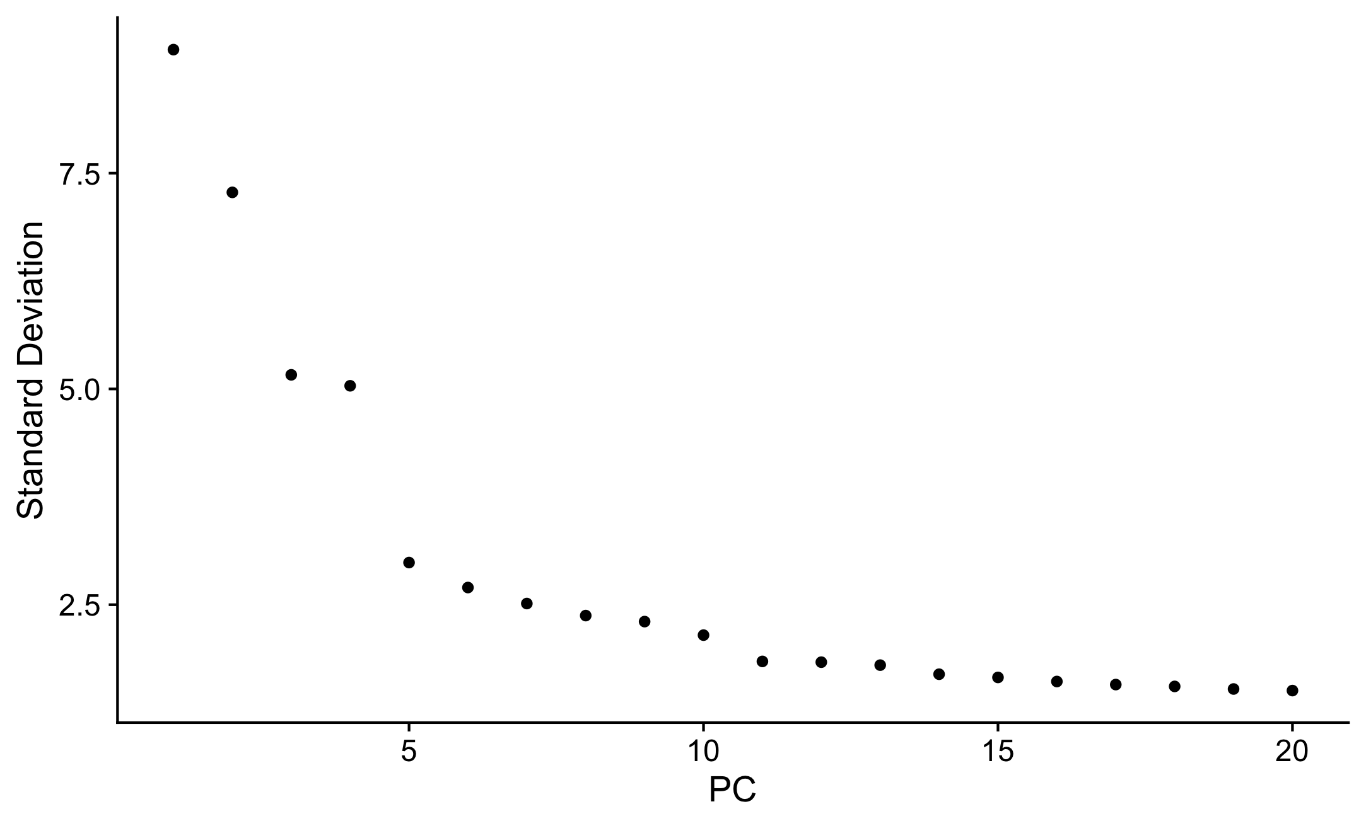

**Fig S4. Elbow plot visualizing the standard deviation of each principal component.**

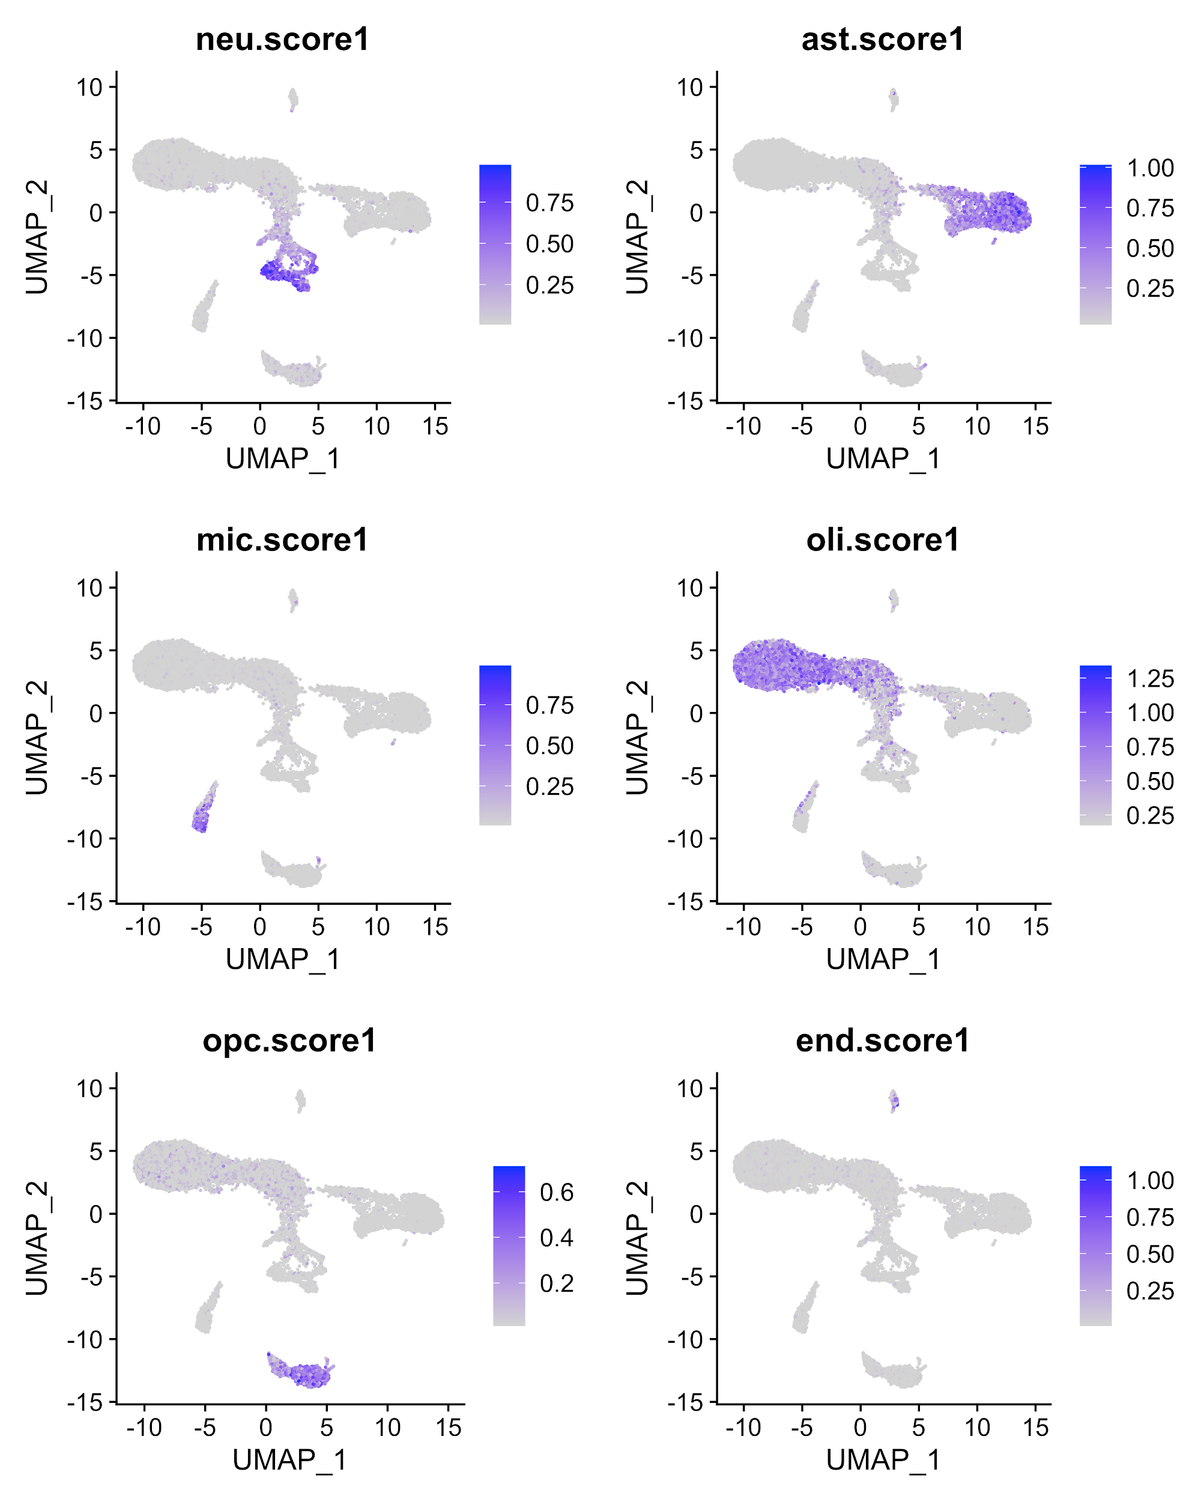

**Fig S5. BRETIGEA scoring cell clusters.** Neu.score1, BRETIGEA score for neurons; ast.score1, BRETIGEA score for astrocytes; mic.score1, BRETIGEA score for microglia; oli.score1, BRETIGEA score for oligodendrocytes; opc.score1, BRETIGEA score for oligodendrocyte progenitor cells; end.score1, BRETIGEA score for endothelial cells.

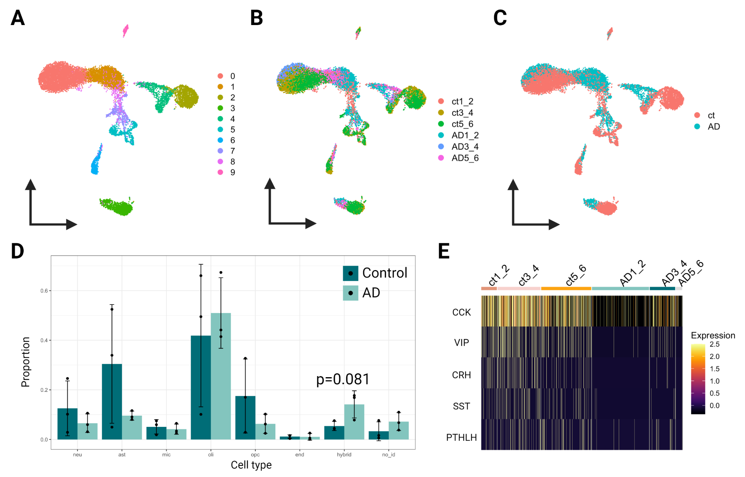

**Fig S6.** (A) Classification by the K-nearest neighbors algorithm. (B) Classification by grouped replicates. (C) Classification by phenotype. Ct, control. (D) A cell type-specific comparison of the cell composition between control and AD entorhinal cortex. Two-tailed Wilcoxon signed-rank test was used. Relative proportion = number of cells expressing gene target for each cell type per biological replicate/number of cells in the cell type per biological replicate. (E) Expression of differentially expressed NPs in neurons using the gene list by Smith et al.

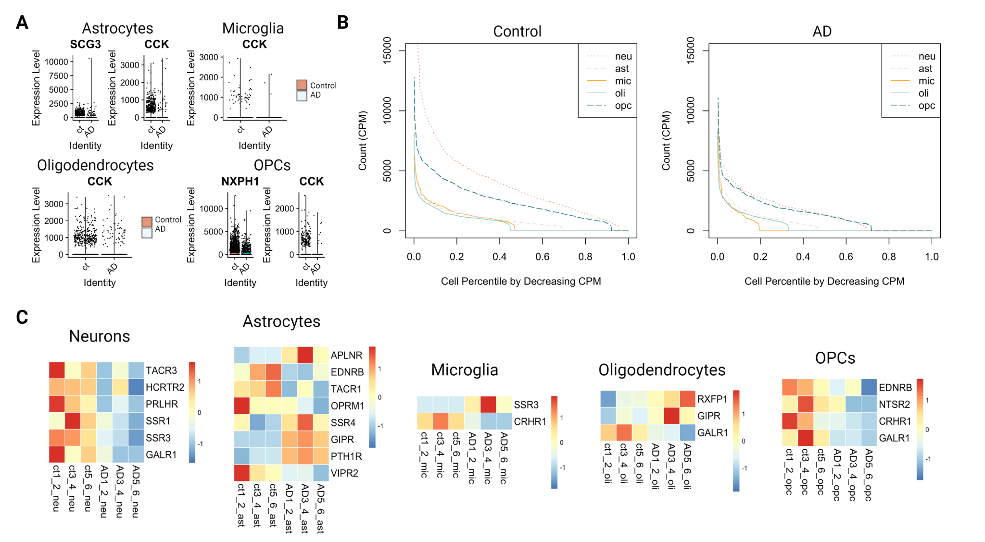

**Fig S7.** (A) Differentially expressed neuropeptide (NP) genes in astrocytes, microglia, oligodendrocytes, and oligodendrocyte progenitor cells (OPCs). Ct, control. (B) The total relative count of all selected NPs plotted against the cell percentile ranked by decreasing cell count in selected cell types in control and AD. (C) Cell type-specific heatmaps showing the G protein-coupled receptor genes expressed by significantly changed (One-tailed Wilcoxon signed-rank test, p<0.1) proportions of cells for each grouped biological replicate. Genes expressed only in one grouped replicate were excluded. Relative proportion = number of cells expressing gene target for each cell type per biological replicate/number of cells in the cell type per biological replicate.

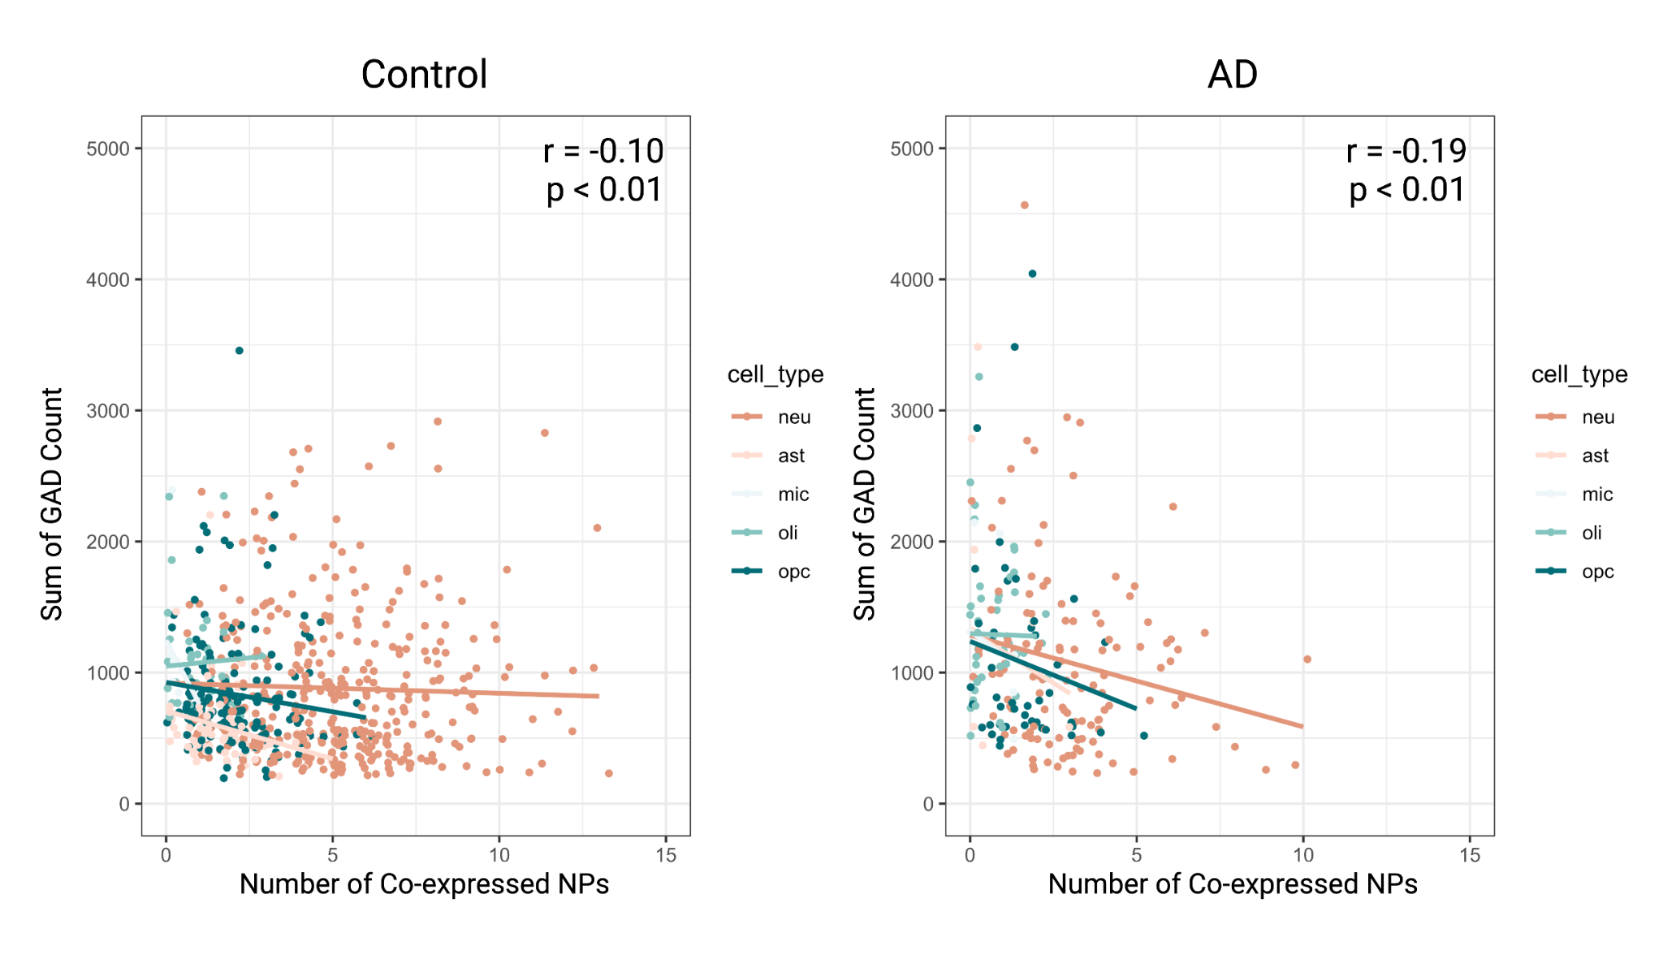

**Fig S8.** **Significant correlation between the sum of the relative number transcripts from GAD (glutamate dehydrogenase) genes and the number of coexpressed NPs shown in both control and AD EC cells.** Pearson's test of correlation was used. r, correlation coefficient.

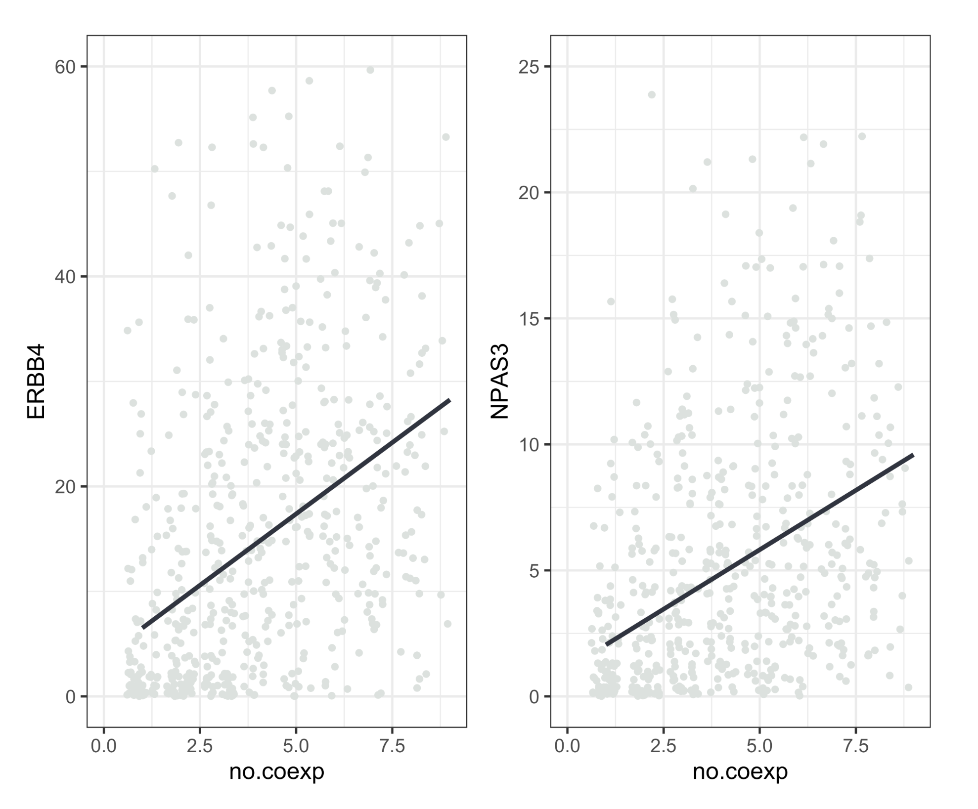

**Figure S9.**

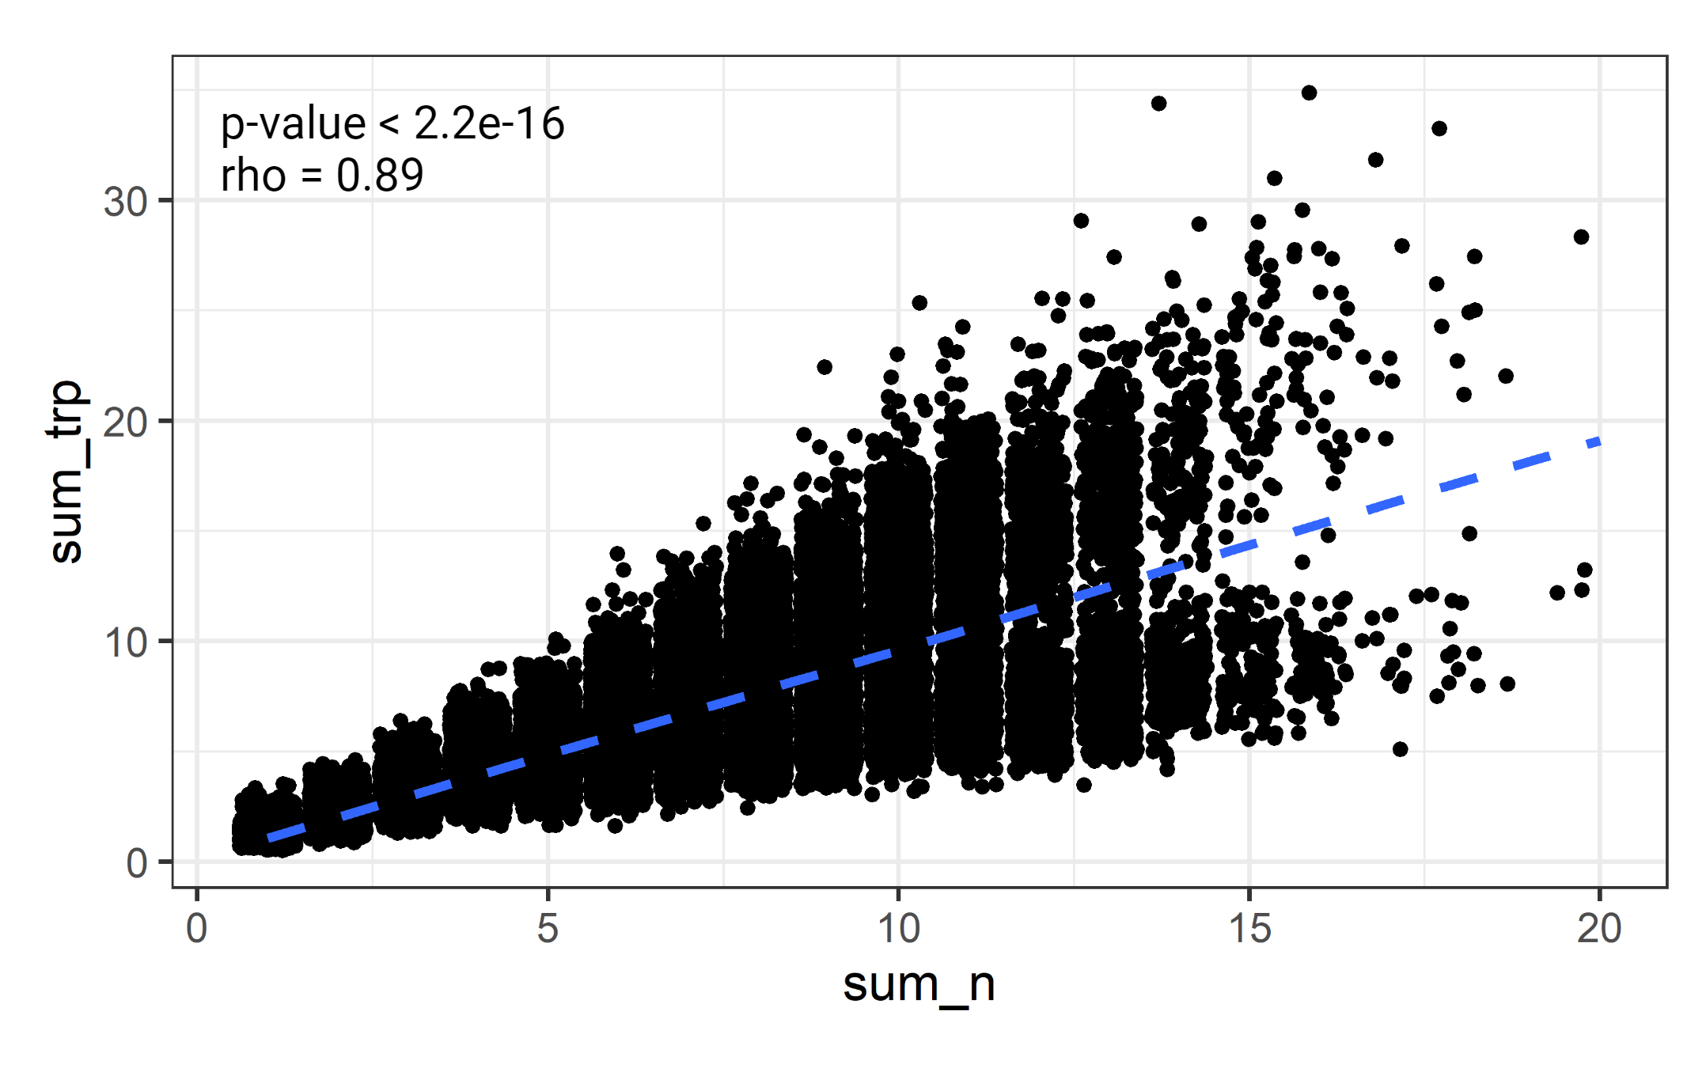

**Figure S10.**